**IBM Flask App Deployment process**

**Cloud foundary cli – installation:-**

* Install cloudfoundary cli,in your local disk using the following link and follow the process for installation

https://github.com/cloudfoundry/cli

* Once you open the link,you’ll redirect to github cloud foundary page
* Under cloud foundary you’ll find downloads
* 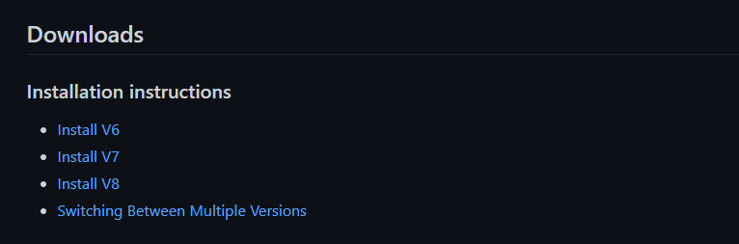
* Click on v6 install and it will land you to the next page ,where you find below details
* 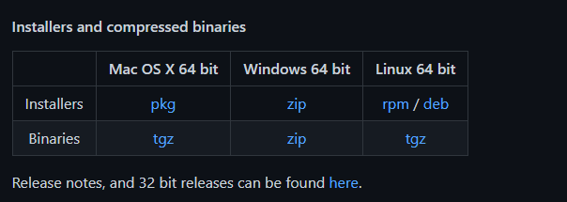
* Windows/os/linux installers –download 64bit version
* Once the zip file gets download,extract and install the cf_installer.exe in your local drive
* 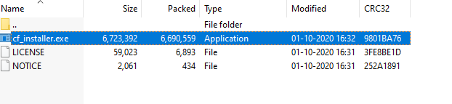

**Process for Flask App creation:-**

* Create flask app in ibm cloud

Type flask app in search bar beside catalogue ,you’ll find flask app under services ,click on it ,it will redirect to this page

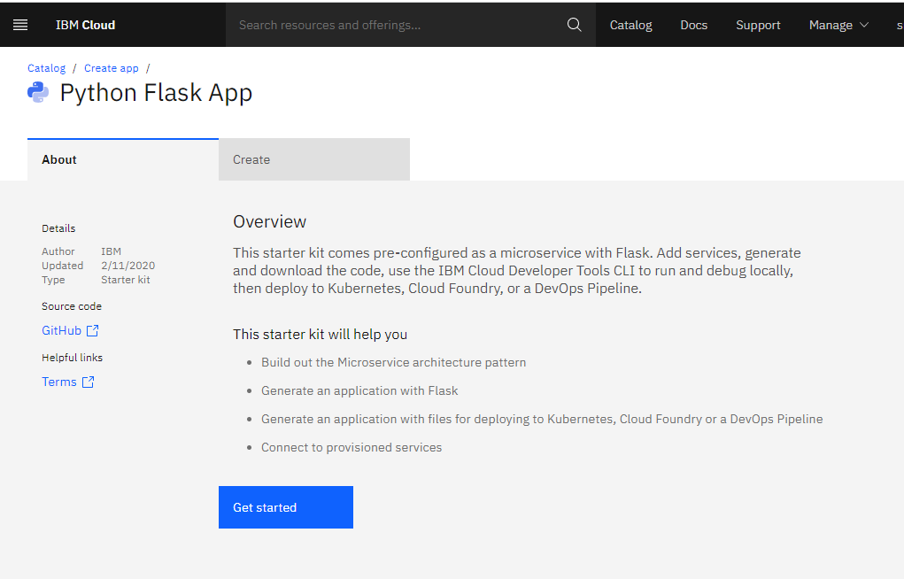

Click on get started ,it will land you to this page

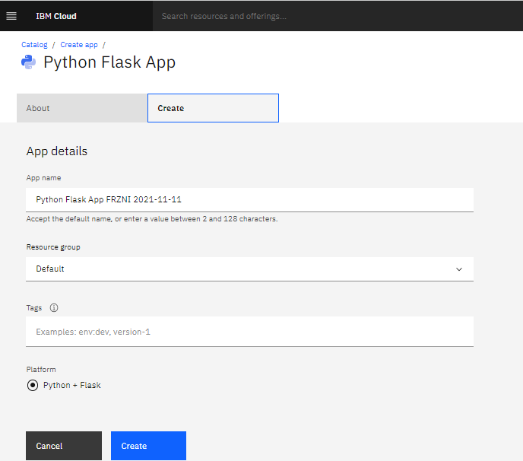

* Give the name and click on create, app is created and it will displayed under

IBM cloud- > resources -> app

* It means that flask app is successfully created,now we need to deploy the model using the flask app

**Files required for flask app deployment:-**

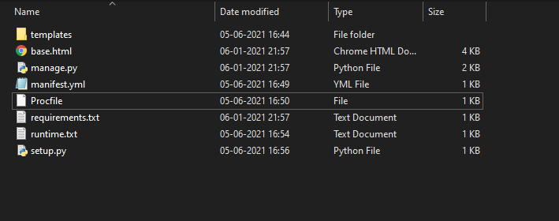

Templates – required HTML pages for user interface

Manage.py/app.py is a flask framework for routing and predicting the values

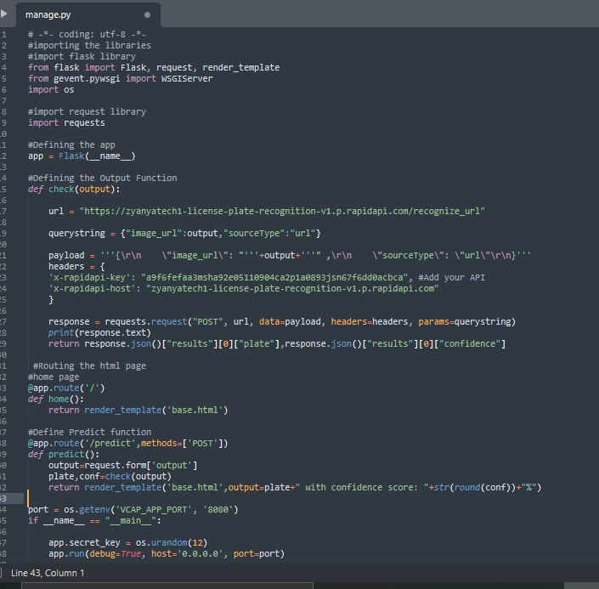

Manifest.yml is YAML file ,which is used to specify the configuration specifications

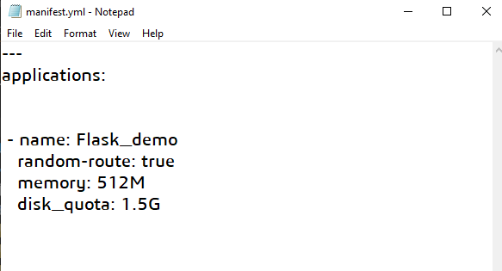

Procfile: used to run the flask file code like we run in anaconda prompt

Python app.py

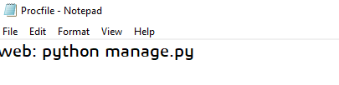

Requirements.txt – it is used to load all the libraries required for model building and deployment.

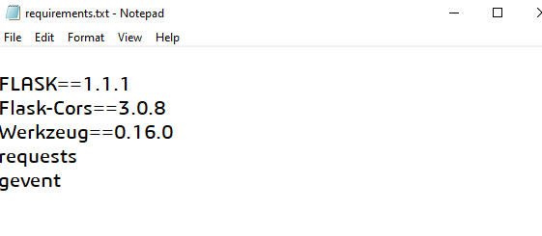

Note: gevent is must file for IBM flask app deployment

Runtime.txt

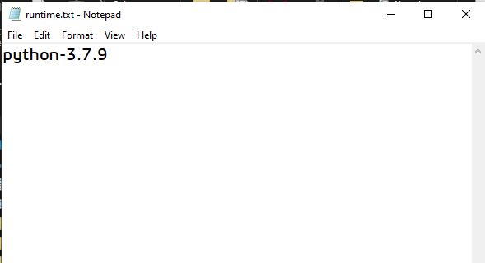

* Used to define the python version used for model building and pushing the code for cloud
* Check the python version of your system and enter it.

Setup.py:-

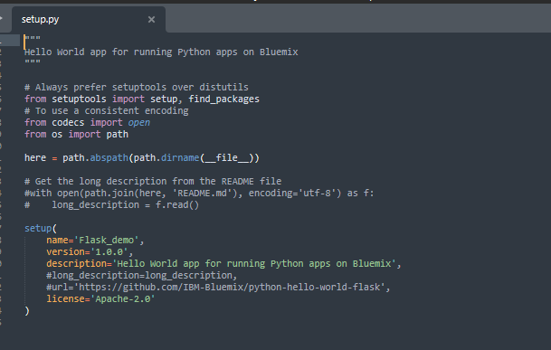

Once all the files are available,keep it in a folder and now we will push the files to flask app using anaconda prompt

**Process for Deployment:-**

* Open anaconda prompt and set the file path using cd <path of the folder>
* After setting the path using the command **cf login**

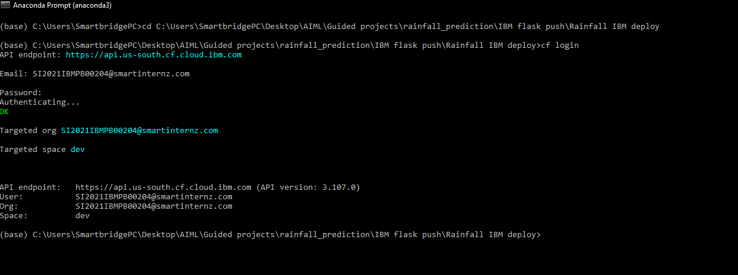

* It will ask you for API endpoint ,search for cloud api end point in google and it will display endpoints,select based on the region you selected while creating cloud

Ex: i selected dallas while creating account, us-south was the region for dallas

* After entering the end point it will ask for mail id to be entered(cloud login id)
* Then it will ask for password,enter the password, password will not be visible but it gets entered
* After successful matching,it will authenticated and login into your account

**Code for pushing into app:-**

* Enter the following code after successful login into the prompt window : cf push “enter the flask app name you created in IBM”
* Ex: **cf push “Python Flask App1”**
* Then click on enter ,it will push all the files to flask application ,it will show successfully completed in the command prompt

**NOTE:** if you encounter any error,use the following command to check the

Error :- **cf logs Python Flask App1**

* Check the error and make the changes in the files
* After successful execution go and check in the ibm resources cloud foundary apps
* You’ll see the app name in the cloud foundary apps,as I see below Flask App1,it will show the status as started

App1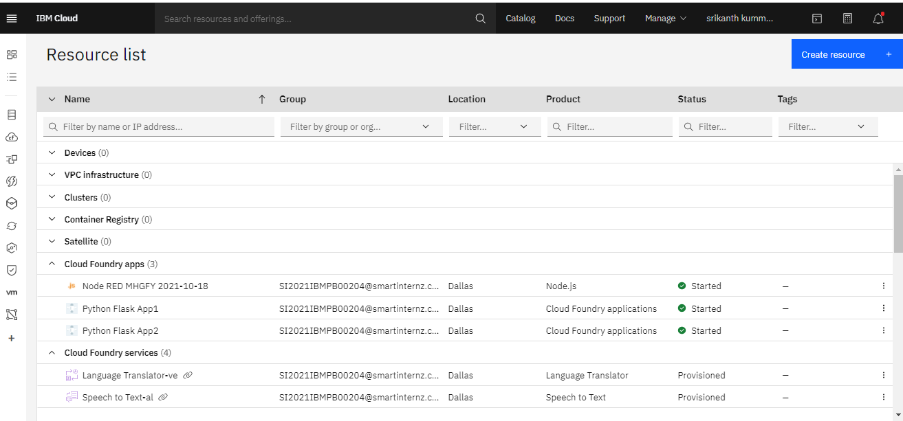

* Click on the python flask app1 under the cloud foundary,It will redirect the next page

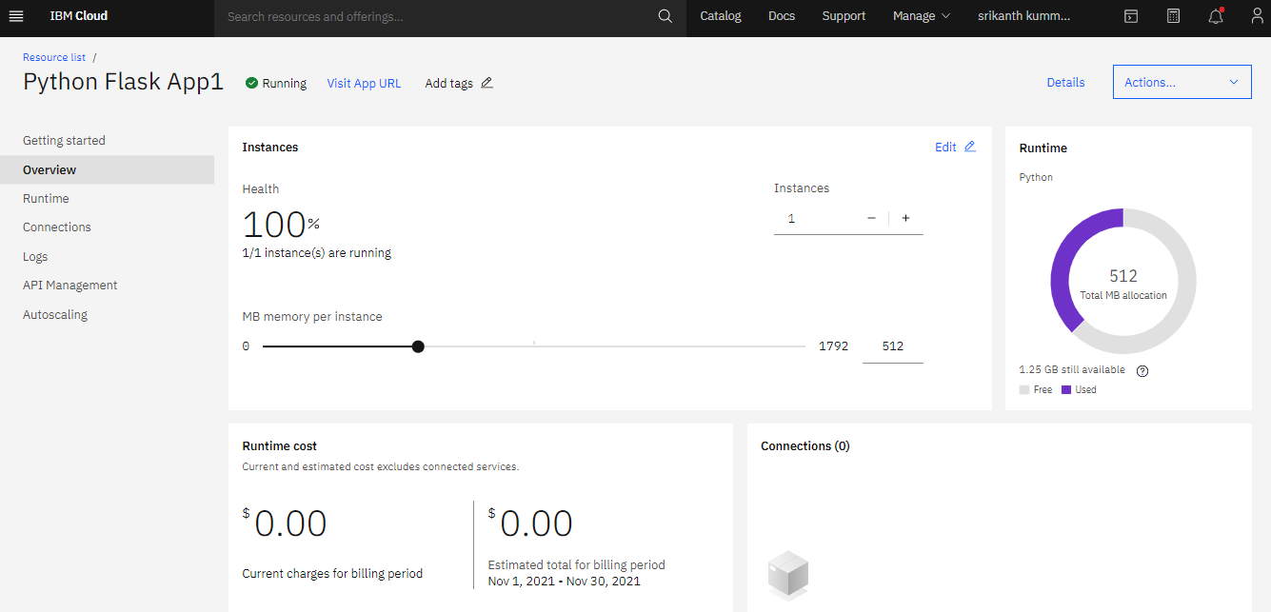

* After successful landing into the above page click on visit url(on the top with blue link)
* It will redirect you to the html page where you can give inputs and predict the output values